When Programs End Overnight: The Impact of the Dismantling of USAID on Persons with Disabilities
Inclusive Development Partners | August 2026 | www.inclusivedevpartners.org
Written by Hidemi Ueno and Anna Martin with data collection conducted by local consultant, Raana Zafar
Pakistan was one of eight study countries in IDP’s mixed‑methods research on the impact of the USAID closure on persons with disabilities. Research was conducted through a global survey, key informant interviews (KIIs), and focus group discussions (FGDs) with government officials, organizations of persons with disabilities (OPD) staff, implementing partners, adults with disabilities, and parents and caregivers of children with disabilities.
Country Overview
Pakistan is a lower‑middle‑income country facing persistent structural economic fragility, high climate vulnerability, and deep social inequities. With a population of 255.2 million in 2025, Pakistan is the 5th most populous country in the world and continues to struggle with rapid demographic growth, uneven human development, and chronic fiscal pressures. Gross Domestic Product (GDP) reached $407.31 billion in 2025, with GDP per capita at $1,595.9, far below regional comparators, reflecting limited productivity growth and constrained formal employment opportunities. Poverty remains widespread: 23% of Pakistanis live below the $3.00/day (2021 PPP) poverty line as of 2024, and food insecurity has worsened, with national Food Insecurity Experience Scale (FIES)‑based food insecurity rising from 15.9% (2018–19) to 24.4% (2024–25). Remittances play a stabilizing role in household welfare and macroeconomic resilience. Pakistan received $38.3 billion in remittances in FY 2024/25, equivalent to 9.9% of GDP in 2025. This reliance underscores structural weaknesses in domestic labor markets and the dependence on external employment opportunities, particularly in Gulf economies.

Pakistan’s development trajectory is shaped by cycles of conflict, insecurity, and displacement. Border instability, localized militancy, and sectarian violence, particularly in Balochistan, southern Khyber Pakhtunkhwa, and parts of Sindh and Punjab, continue to disrupt livelihoods and access to services. Rural households in these regions face compounded risks: limited state presence, weak infrastructure, and exposure to both economic and climate shocks. Internal displacement remains a recurring challenge, driven by conflict, natural disasters, and economic pressures. Chronic insecurity restricts mobility, depresses investment, and limits educational continuity in affected districts in Pakistan. These long‑term stressors have contributed to rising malnutrition and food insecurity, with acute malnutrition remaining persistently high across multiple provinces.

Pakistan ranks among the top 10 countries globally most affected by extreme weather events. Its arid to semi‑arid climate, dependence on the Indus River system, and high exposure to monsoon variability make rural livelihoods extremely sensitive to climate shocks. Agriculture is the primary livelihood for millions, with the Indus system supporting about 90% of national agricultural production. Recent years have seen repeated climate disasters, and environmental pressures exacerbate rural poverty, disrupt schooling, and strain government capacity to deliver resilient services.

Pakistan faces a profound human capital challenge. The Human Capital Index stands at 0.41, reflecting significant gaps in learning, health, and nutrition. Prior to COVID‑19 and the 2022 floods, over 20 million children were out of school. Learning poverty remains severe, with high dropout rates driven by economic hardship, gender norms, insecurity, and limited access to quality schools. Female labor force participation remains low. Access to electricity is high at 95.7% (2024), but rural service quality remains uneven, and Unemployment stands at 5.4% (2025). Underemployment and informal work dominate the labor market. These constraints contribute to a persistent skills gap, limiting youth participation in formal employment and emerging economic sectors.

Pakistan’s disability prevalence remains difficult to measure accurately; while the Pakistan Bureau of Statistics reports 3.1% of the population has disability in the 2023 National Census Report, the Demographic and Health Survey 2017-2018 reports 13% of household members age 5 or above have some level of difficulty. Persons with disabilities face systemic barriers to education, employment, healthcare, and social protection, with limited access to rehabilitation and assistive devices, especially outside major cities, and persistent gaps in data, financing, and institutional capacity. Although Pakistan has made policy commitments under the Convention on the Rights of Persons with Disabilities (CRPD), implementation remains slow, and OPDs continue to operate with constrained resources, limiting meaningful inclusion.

Pakistan’s rising poverty, limited human capital, and acute climate vulnerability make external investment vital for sustainable development. With constrained fiscal space and overstretched public services, the government cannot expand education, health, or social protection systems at the scale required, making long‑term international support essential for strengthening resilience, advancing inclusion, and enabling more equitable growth.
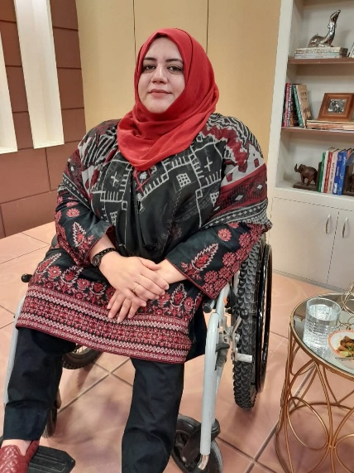
USAID in Pakistan
Pakistan has been a long‑standing recipient of U.S. foreign assistance, particularly in areas related to economic stabilization, humanitarian response, climate resilience, education, and governance. The figures below reflect total U.S. foreign assistance and USAID sector allocations. Disability‑specific funding is not reported as a separate line item in publicly available U.S. government data.
- Pakistan received approximately $170 million in total U.S. foreign assistance in FY 2024, covering economic growth, governance, education, health, and humanitarian sectors.
- USAID obligations totaled $116 million in FY 2024 for Pakistan. Sector totals on ForeignAssistance.gov show health and population receiving $26 million, governance receiving $18 million, humanitarian receiving $18 million, and economic growth receiving $14 million.
- USAID’s Bureau for Humanitarian Assistance (BHA) provided significant support for flood response, drought mitigation, and climate‑resilient agriculture. Following the 2022 catastrophic floods, USAID provided Pakistan over $200 million in humanitarian assistance for shelter, food security, health, and early recovery.
- USAID was one of the largest bilateral donors supporting Pakistan’s education, youth inclusion, and workforce development. USAID’s education portfolio in Pakistan included:
  - School Reconstruction and Rehabilitation (Post‑2022 Floods)
  - Institutional Capacity‑Building for Universities
  - Girls' education initiatives
  - Literacy programs
  - Teacher trainings
  - Youth Skills and Workforce Development Programs

Programs in Pakistan were terminated as a result of USAID's dismantling, including the ERA Project. IDP was a partner on this project, supporting the Government of Pakistan in strengthening inclusive education systems and improving access to learning for children with disabilities. The project worked with provincial education departments, school leaders, and teachers to expand disability‑inclusive practices, improve early identification of learning needs, and increase access to appropriate learning supports. IDP delivered technical assistance on inclusive pedagogy, supported the development of accessible teaching and learning materials, and helped build school‑level capacity to identify and reduce barriers to participation for children with disabilities. The initiative also engaged families and communities to promote inclusive attitudes and ensure continuity of learning for children with disabilities in underserved areas.
This $2 million USAID‑funded cooperative agreement was designed to strengthen inclusive education systems across priority districts in Khyber Pakhtunkhwa and Sindh. Although the project had only recently begun implementation, early achievements laid the groundwork for long‑term impact. The abrupt suspension of USAID development assistance halted the project before full rollout.
- Provincial UDL and inclusive education integration: In its initial phase, the project completed a comprehensive capacity and needs assessment of provincial education systems, identifying gaps in inclusive education readiness. These findings informed draft provincial implementation plans and early efforts to integrate Universal Design for Learning (UDL) and Social‑Emotional Learning (SEL) approaches into teacher training structures and curriculum guidance.
- Development of inclusive instructional training modules: Before suspension, the project developed UDL‑aligned training modules for teacher educators, school leaders, and district officials. These modules introduced practical tools for adapting instruction, creating accessible learning materials, and supporting diverse learners. Full-scale teacher rollout had not yet begun.
- Strengthening school‑level support systems: Early work with school directors and district education offices focused on developing inclusive school improvement plans, strengthening school‑based support systems, and integrating SEL‑based psychosocial support strategies. These efforts were in the planning and pilot stages when the project was halted.
- Capacity building for provincial government teams: The project provided initial technical assistance to provincial education departments on inclusive education, UDL, and accessible learning design. This early capacity-building was intended to support long‑term policy alignment and curriculum development, but further phases were cancelled due to the suspension.
- Cross‑cutting inclusion mainstreaming: Across all components, the project established inclusion as a cross‑cutting priority. Disability‑inclusive approaches were integrated into teacher training, instructional material development, school coaching, and community engagement. While frameworks and guidance were developed, full implementation was not possible due to the early closure.
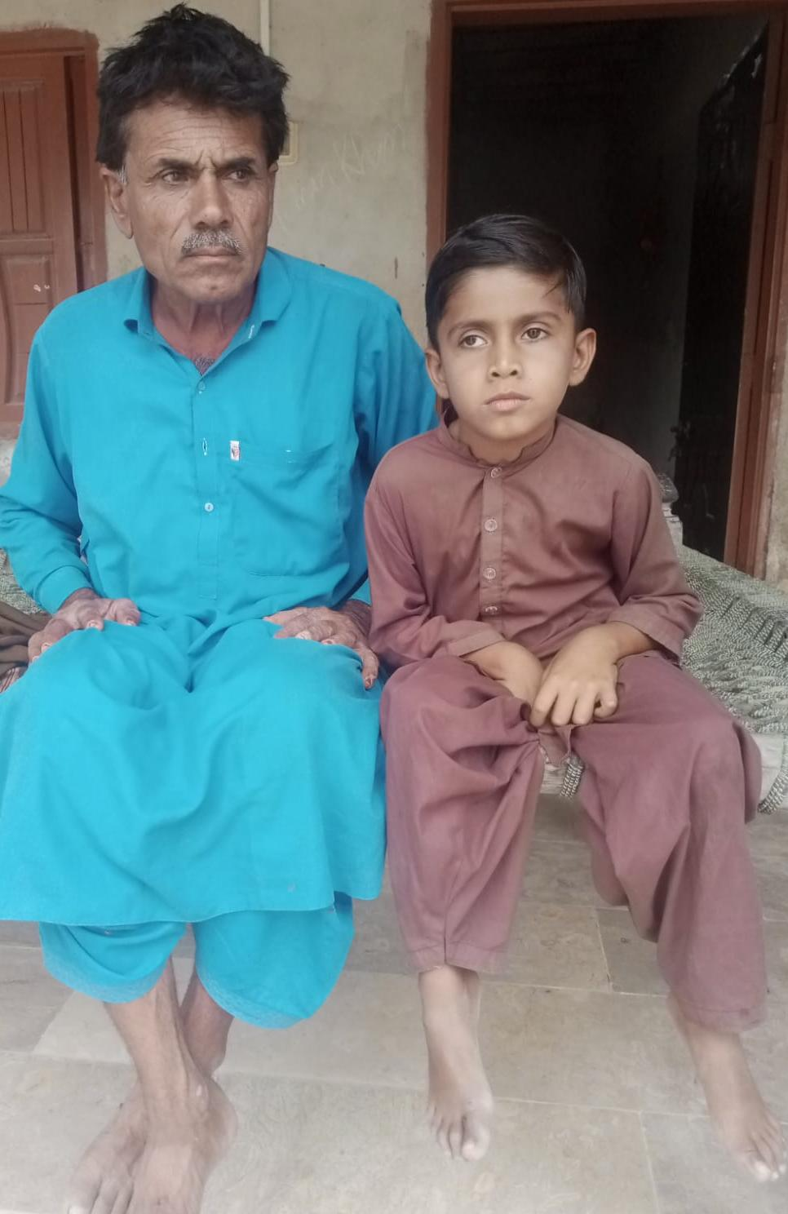
IDP Research Findings on the Impact of the USAID Dismantling on Persons with Disabilities

SUMMARY OF THE METHODS AND RESEARCH IN PAKISTAN
This study employed a mixed-methods design to document the impact of USAID program terminations on persons with disabilities, their families, and the organizations and systems that served them. Data were collected concurrently through three methods: an online survey, key informant interviews (KIIs), and focus group discussions (FGDs). Findings from all streams were triangulated during analysis. In Pakistan, data was collected from 3 government officials, 3 parents/caregivers of children with disabilities, and 2 OPDs. The study was conducted under Institutional Review Board (IRB) approval from the University of Massachusetts Boston.
The findings below draw entirely from evidence collected in Pakistan, including interviews with government officials, OPDs, caregivers, adults with disabilities, and curriculum authorities.
Finding 1: Inclusive education momentum collapsed, leaving children with disabilities without meaningful pathways into mainstream schooling.
Before the closure, USAID‑supported activities had begun shifting long‑standing beliefs about disability and schooling. Government officials described the orientation as the first time they understood inclusive education correctly, noting that it directly challenged the entrenched assumption that “special children should be educated separately.”

“This was the first true understanding of ‘Inclusive Education’… our previous understanding was completely opposite.”
— Government official, Khyber Pakhtunkhwa (KP)

The Education Resilience Activity (ERA) project was still in its early stages, but it had already prepared teacher training modules, pulled together technical working groups, and initiated provincial inclusive education curriculum alignment. The abrupt closure forced the government to pause all USAID‑linked activities. Fortunately, the Sindh region later secured limited support from Health and Nutrition Development Society (HANDS) and the Department of Empowerment of Persons with Disabilities (DEPD) to finalize the inclusive education curriculum framework, However, the cascading teacher training, essential for classroom‑level change, remains unfunded.

“But the ground had been prepared and whatever positive impact could have come could not be hoped for now.”
— Senior Government Official, Sindh

Caregivers in Sindh reported that their children continued to face stigma, misdiagnosis, and exclusion because teachers lacked preparation:

“Teachers assume he can’t understand.”
— Caregiver, Sindh

Without USAID’s support, inclusive education efforts stalled, and families now face untrained teachers, persistent misconceptions, and no adapted learning materials.
Finding 2: Caregivers of children with disabilities lost anticipated supports, screenings, and school‑level improvements that would have enabled early identification and inclusion.
Families in rural Sindh described USAID’s planned activities as a rare opportunity for their children to receive screenings, adapted materials, and teacher attention. These supports never materialized due to the premature closure.

“We were told that the Project would be training teachers to teach children like Abdul Razzaque.”
— Caregiver of a child with a disability, Sindh

Parents emphasized that without teacher training, their children remain misunderstood, isolated, and at risk of falling behind. The closure also eliminated community spaces where families met, shared information, and accessed informal support, compounding isolation in rural areas already facing school closures due to floods and political instability.

One parent hadn’t even realized that the projects had been cancelled at the time of the interview. When asked, “How and when did you come to learn that this project was no longer active?”:

“Just now when you are talking to me.”
— Caregiver of a child with a disability, Sindh
Finding 3: OPDs lost employment, institutional capacity, and momentum toward disability‑rights reforms.
OPDs across Pakistan described severe operational setbacks. Staff lost jobs, outreach shrank, and long‑term advocacy efforts were derailed.

“The funding cannot simply stop. People with disabilities cannot wait another decade. For many, these programs are a lifeline. Advocacy matters — this matter should be brought to the attention of international media.”
— OPD representative, Islamabad

The closure halted progress toward inclusive election reforms, disability‑rights legislation, and national‑level advocacy platforms. OPDs emphasized that USAID had been the most consistent donor supporting disability inclusion, and its withdrawal left a vacuum that other donors have not filled.

“The technical working groups which were created would have increased our credibility, and amplified the voice of [the] disability community on important forums are also gone.”
— OPD representative, KP
Finding 4: Adults with disabilities lost employment opportunities, mobility supports, and pathways to independence.
USAID‑funded projects had begun creating professional opportunities for persons with disabilities, including roles in governance, advocacy, and inclusive education. The closure abruptly ended these pathways.

“Our staff had been hired… 17 core team members and 40 project staff lost employment. Many were women and persons with disabilities.”
— OPD representative, Islamabad

“I had received a job offer… but they told me the funding is no more.”
— Adult with disability, KP

Loss of employment meant loss of mobility, financial independence, and access to assistive devices. Many individuals were forced to relocate or remain unemployed for extended periods.

“This opportunity would have enabled me to continue living with my family and be financially independent.”
— Adult with disability, KP
Finding 5: Government systems lost technical guidance, coordination mechanisms, and the continuity needed to institutionalize inclusive education.
Government officials across KP and Sindh described the closure as a major setback to system strengthening. USAID’s technical partners had been providing specialized guidance on pedagogy, curriculum design, and inclusive instructional practices. Their withdrawal left ministries without the expertise needed to sustain reforms.

“We don’t have people trained in this domain… USAID had just started to address this.”
— Government Official, Sindh

Teacher training gaps have widened, especially for the 90,000+ newly recruited teachers who require structured, high‑quality induction and inclusive pedagogy training.
What Must Happen Next
The Pakistan findings point to urgent, actionable steps for donors, government partners, and the U.S. Congress.
- Rebuild inclusive education capacity through renewed donor investment. Teacher training, adapted materials, and inclusive pedagogy must be reinstated. Without this, children with disabilities will continue to face exclusion and learning poverty.
- Support OPDs with direct, flexible funding to restore outreach and advocacy. OPDs lost staff, mobility supports, and institutional momentum. They are now the primary lifeline for families who lost access to services overnight.
- Fund provincial rollout of inclusive curriculum frameworks and teacher training. Sindh’s inclusive education framework is ready but unfunded. KP’s Master Trainer pipeline must be rebuilt.
- Reinstate early identification and screening services for children. Vision, mobility, and developmental screenings are essential for rural families who cannot afford private care.
- Strengthen municipal and district‑level disability systems. Referral pathways, school‑level support systems, and community engagement mechanisms must be rebuilt to prevent long‑term regression.
- Require transition protocols for all donor‑funded programs. The abrupt termination caused immediate service collapse. Future programs must include mandatory transition planning.
- Protect disability‑inclusive programming from political reversals. Accessible materials, sign language interpretation, and disability‑disaggregated data must be safeguarded under U.S. law.
- Recognize disability inclusion as a stabilizing force in Pakistan. Investments in inclusive education, OPDs, and caregiver support strengthen community resilience in contexts of poverty, instability, and climate vulnerability.
This brief draws on findings from When Programs End Overnight: The Impact of the Dismantling of USAID on Persons with Disabilities (IDP, 2026). The full report is available at www.inclusivedevpartners.org. For more information, contact Inclusive Development Partners.
Photo Credits: Raana Zafar, local consultant of the IDP

World Bank. (2026). Pakistan: Country data. World Bank Open Data. https://data.worldbank.org/country/pakistan
ReliefWeb. (2026, May 26). Pakistan: Special report – May 26, 2026. United Nations Office for the Coordination of Humanitarian Affairs (OCHA). https://reliefweb.int/report/pakistan/pakistan-special-report-may-26-2026
Ibid.
World Bank. (2026). Pakistan: Country data. World Bank Open Data. https://data.worldbank.org/country/pakistan
ACAPS. (n.d.). Pakistan. ACAPS. https://www.acaps.org/en/countries/pakistan
ReliefWeb. (2026, May 26). Pakistan: Special report – May 26, 2026. United Nations Office for the Coordination of Humanitarian Affairs (OCHA). https://reliefweb.int/report/pakistan/pakistan-special-report-may-26-2026
World Bank. (2023). Pakistan education sector analysis: Key challenges and reform priorities (Report No. IDU0e363697f0c0a08974030051e1ec772). https://documents1.worldbank.org/curated/en/099945103292317217/pdf/IDU0e363697f0c0a08974030051e1ec772.pdf
ReliefWeb. (2026, May 26). Pakistan: Special report – May 26, 2026. United Nations Office for the Coordination of Humanitarian Affairs (OCHA). https://reliefweb.int/report/pakistan/pakistan-special-report-may-26-2026
World Bank. (2023). Pakistan human capital review: Building capabilities throughout life. World Bank Group. https://www.worldbank.org/en/region/sar/publication/pakistan-human-capital-review-building-capabilities-throughout-life
World Bank. (2026). Pakistan: Country data. World Bank Open Data. https://data.worldbank.org/country/pakistan
Pakistan Bureau of Statistics. (2023). National Census Report 2023. Government of Pakistan. https://www.pbs.gov.pk/wp-content/uploads/2020/07/National-Census-Report-2023.pdf
National Institute of Population Studies (NIPS) [Pakistan], & ICF. (2019). Pakistan demographic and health survey 2017–18 (FR354). DHS Program. https://dhsprogram.com/pubs/pdf/FR354/FR354.pdf
ForeignAssistance.gov. (2024). Pakistan: FY2024 U.S. foreign assistance obligations (USAID). U.S. Government. https://foreignassistance.gov/cd/pakistan/0/2024/obligations
ForeignAssistance.gov. (2024). Pakistan: FY2024 U.S. foreign assistance obligations (Department of State). U.S. Government. https://foreignassistance.gov/cd/pakistan/1/2024/obligations
U.S. Agency for International Development. (2022). USAID announces funding to support flood-affected communities in Pakistan. U.S. Embassy Islamabad. https://pk.usembassy.gov/usaid-announces-funding-to-support-flood-affected-communities-in-pakistan/
Zero Period. (2025, May). Shrinking aid, growing crisis: Education in Pakistan at risk amid USAID funding cuts. https://zeroperiod.com.pk/2025/05/shrinking-aid-growing-crisis-education-in-pakistan-at-risk-amid-usaid-funding-cuts/
Khan, A. (2025, February). What the U.S. aid suspension means for Pakistan. The Diplomat. https://thediplomat.com/2025/02/what-the-us-aid-suspension-means-for-pakistan/
Inclusive Development Partners. (2024). Pakistan: School for All. https://www.inclusivedevpartners.com/pakistan-school-for-all/
Ibid.
Inclusive Development Partners. (2024). Capacity needs and training assessment: Khyber Pakhtunkhwa (Draft report). https://www.inclusivedevpartners.com/wp-content/uploads/CNA-Report-Draft_KP-for-TA-review.docx

