COUNTRY BRIEF: NIGERIA
When Programs End Overnight: The Impact of the Dismantling of USAID on Persons with Disabilities
Inclusive Development Partners | June 2026 | www.inclusivedevpartners.org
Nigeria was one of eight study countries in IDP's mixed-methods research on the impact of the USAID closure on persons with disabilities. Research was conducted through a global survey, key informant interviews (KIIs), and focus group discussions (FGDs) with government officials, OPD staff, implementing partners, adults with disabilities, and parents and caregivers of children with disabilities. Local researcher Suleiman Mamman led data collection in Nigeria.
Country Overview
Nigeria is Africa's largest economy by total GDP, yet it is also the largest contributor to multidimensional poverty in sub-Saharan Africa. Nigeria's GDP per capita stood at approximately $824 in 2024, down from over $3,000 a decade ago, despite the country having Africa's largest total GDP. Unfortunately, oil wealth has not translated into broad-based economic development.Approximately 41% of Nigerians, 81 million people, are multidimensionally poor according to the 2024 global Multidimensional Poverty Index, making Nigeria the largest contributor to multidimensional poverty in sub-Saharan Africa. Extreme poverty rose from 31% in 2019 to 38.9% in 2023, driven by the COVID-19 pandemic, high inflation, currency depreciation, and climate shocks. On the current trajectory, extreme poverty is projected to remain well above regional averages through 2043. This paradox of extreme wealth alongside mass poverty explains why sustained external development investment is not supplementary but structural.
In addition to systemic poverty, parts of Nigeria (especially the northern states of Borno, Yobe, and Adamawa) are also plagued by political turmoil. Boko Haram, which translates to “Western education is forbidden," has been inflicting instability and violence within the Northern states of Nigeria. The group's founding ideology was explicitly built on the rejection of formal education and the grievances of communities who felt that Western schooling produced inequality, not opportunity. Between 2009 and 2015, Boko Haram destroyed more than 910 schools and forced at least 1,500 more to close. At least 611 teachers were deliberately killed, and another 19,000 forced to flee. More than 2,000 civilians, many of them women and girls, were abducted, including the 276 girls taken from Chibok Government Secondary School in 2014. The deliberate targeting of schools was not incidental but strategic: by destroying formal education infrastructure, Boko Haram eliminated an alternative path for young people and deepened the conditions of idleness and deprivation that drive recruitment.
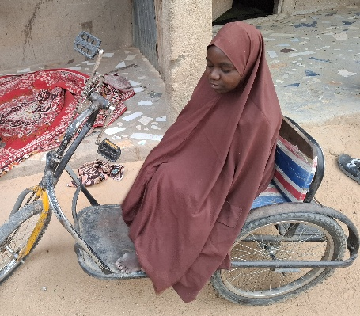
Due to these challenges, Nigeria has one of the highest numbers of out-of-school children globally, with more than 10.5 million children not attending school despite policies mandating free and compulsory primary education. The conflict caused by Boko Haram has displaced more than 3.3 million people in the Lake Chad Basin region, nearly half of whom are children. The northeast states of Borno, Yobe, and Adamawa bear the most concentrated impact. Over 1,697 schools were closed in northeastern Nigeria as of 2016, including 1,063 in Borno state alone. An estimated 1,400 schools have been destroyed, damaged, or looted, and more than 19,000 teachers have been displaced or killed since 2009. Sustained development investment in marginalized communities, particularly inclusive quality education, has been documented as effective in diminishing the appeal of radical ideologies. Research shows that active engagement of youth in structured learning environments reduces idleness, builds social cohesion, and equips young people with economic alternatives to recruitment.
USAID in Nigeria
Nigeria was one of the largest recipients of U.S. foreign assistance globally before the dismantling. The figures below reflect total USAID funding across all sectors. Disability-specific funding is not reported as a separate line item in publicly available data.
- Nigeria received approximately $930 million in total U.S. foreign assistance in FY 2024, making it the 7th largest recipient globally and the 3rd largest in Africa, behind only the Democratic Republic of Congo ($1.3 billion) and Ethiopia ($1.25 billion).
- Over the three-year period from 2022 to 2024, Nigeria received a total of $2.75 billion from USAID. Of this, $1.47 billion went to health, $887 million to humanitarian services, $141 million to economic development, and $41.75 million to education.
- Of the $930 million disbursed in 2024, approximately $24.3 million (2.6%) was allocated to education. Health represented the largest sector, accounting for 51.73% of total USAID spending in Nigeria from 2020 to 2024.
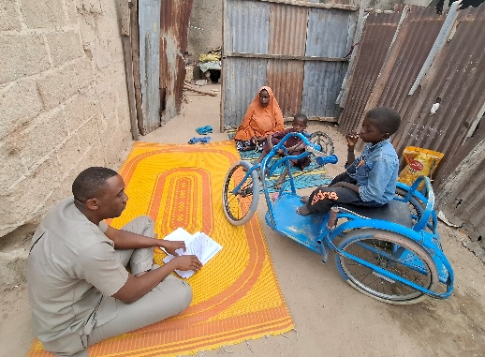
Two flagship education programs in Nigeria were terminated due to the USAID dismantling: Leveraging Education Assistance Resources in Nigeria (LEARN) to Read (2022–2026) and Opportunities to Learn (OtL) (2022–2027). IDP was a partner on OtL, delivering inclusive education programming in Northern Nigeria through the International Rescue Committee. This $25 million cooperative agreement operating across Borno, Adamawa, and Yobe (BAY) states was highly successful. A few of the achievements in year three of operation include:
- Scale and reach: 1,461 Non-Formal Learning Centers across 385 communities, reaching 159,716 learners against a life-of-project target of 203,410, with 60,691 enrolled in Year 3 alone.
- The BECE first: out-of-school children were enrolled continuously from the foundational level through Junior Secondary and sat for the Basic Education Certificate Examination, with formal fee and uniform waivers secured from Borno and Yobe; 5,075 learners sat for the exam in total.
- Learning outcomes: reading proficiency rose from a 6.3% baseline to 38% (hitting the target) and math from 27.8% to 48% (exceeding the 40% target), with 53% of learners transitioning to further education, beating the 47% target.
- Disability inclusion specifics: 1,277 children with disabilities enrolled, 39 received mobility devices, hospital MOUs secured vision and hearing diagnostics, and a blind Learning Facilitator was recruited and deployed to teach Braille to a visually impaired learner, with parallel work underway to expand support for deaf students across the three states.
- Gender parity reversal: girls made up 57.8% of enrollment, with the gender intake gap at -5.3%, meaning girls enrolled at higher rates than boys, against a 10% benchmark.
The Perry Allegations and Their Consequences for NGOs in Nigeria
On February 13, 2025, Republican Congressman Scott Perry of Pennsylvania, speaking at the inaugural hearing of the Subcommittee on Delivering on Government Efficiency, titled 'The War on Waste: Stamping Out the Scourge of Improper Payments and Fraud,' alleged without providing evidence that USAID was channeling $697 million annually to fund ISIS, Al-Qaeda, Boko Haram, ISIS Khorasan, and terrorist training camps. He stated directly: 'You are paying for terrorism.' His primary stated evidence concerned school construction in Pakistan, not Nigeria. Boko Haram was named in the same sentence as global jihadist networks in a congressional hearing that was widely covered by Nigerian media.
The statement was unsubstantiated, was refuted at the highest diplomatic level, and its author subsequently retreated from it. But the damage it caused in Nigeria was real, immediate, and documented. Perry's statement triggered a formal parliamentary investigation in Nigeria. A committee of the House of Representatives sent letters to civil society organizations, including Transparency International Nigeria, informing them of a probe 'with a view to unraveling their real identities, sources of funding and what they expend their monies on,' explicitly citing Perry's comments as the basis. Organizations were required to provide audited financial statements covering 2015 to 2024. Some groups described the investigation as a clampdown on free speech and a tool to undermine accountability work. Nigeria's Senate summoned key security officials, including the National Security Adviser and the heads of the National Intelligence Agency and the Defense Intelligence Agency, to a closed-door session to address the allegations.

IDP Research Findings on the Impact of the USAID Dismantling on Persons with Disabilities
SUMMARY OF THE METHODS AND RESEARCH IN NIGERIA
This study employed a mixed-methods design to document the impact of USAID program terminations on persons with disabilities, their families, and the organizations and systems that served them. Data were collected concurrently through three methods: an online survey, key informant interviews (KIIs), and focus group discussions (FGDs). Findings from all streams were triangulated during analysis. In Nigeria, data was collected from 6 government officials, 4 parents/caregivers of children with disabilities, and 2 OPDs. The study was conducted under Institutional Review Board (IRB) approval from the University of Massachusetts Boston.
The findings below are drawn entirely from evidence collected in Nigeria, with a focus on Northeast Nigeria, where USAID-supported education, health, and nutrition programming for children with disabilities was most extensive. An
Finding 1: Northeast Nigeria was the site of a historic first for children with disabilities in the country's education system, achieved through years of relationship-building that closure has now severed.
For the first time in Nigeria's basic education history, out-of-school children, including 1,277 children with disabilities enrolled in Year 3 alone, were enrolled continuously from the foundational level through Junior Secondary School and sat for the Basic Education Certificate Examination, after USAID-supported programming secured formal fee and uniform waivers from Borno and Yobe state governments. A blind Learning Facilitator with Braille expertise had been recruited and deployed to a community in Adamawa specifically to support a single visually impaired learner, work made possible only by years of relationship-building with local OPDs and government counterparts. A hospital partnership with the University of Maiduguri Teaching Hospital, formalized in February 2024 after years of relationship development, was providing free vision and hearing diagnostics for children with disabilities. None of this infrastructure was transferred. The hospital MOU is no longer honored, and the Braille placement model has not been replicated elsewhere.
Furthermore, government officials and OPDs pointed to the reversal of efforts to domesticate inclusive education policy in Brono State, not just leading to a loss of services, but a rollback of legal and policy reform that had been in motion for years. Weakened coordination and the loss of technical support has also led to inclusive data not being collected which will lead to children with disabilities being invisible in education data systems.
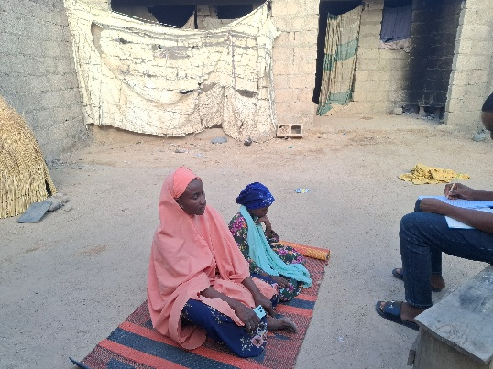
Finding 2: Closure pushed children with disabilities back into a conflict environment that USAID programming had been actively working to counter.
"Our children are out on the streets due to the closure."
– Mother, Northern Nigeria
Children with disabilities in Northeast Nigeria were already eight to ten times more likely to be out of school than their peers before any conflict-related disruption. When programming ended, 75 percent of students in one accelerated education program dropped out and returned to the streets, back into the idle, unsupervised conditions that have long made children vulnerable to Boko Haram recruitment. This is not a generic finding about service loss; it is a finding about a specific, named security risk in a region where armed conflict and education access are directly linked. A government respondent captured the loss in personal terms: "We hoped these children would become our future leaders. However, the project was sadly discontinued."
Girls with disabilities who are out of school are at a heightened risk of being married and experiencing gender-based violence. Caregivers connect the loss of education to the likelihood of girls with disabilities being married early if they are left idle at home or being increasingly exposed to sexual exploitation.
Finding 3: OPDs that had become the public face of USAID programming in their communities absorbed the anger of communities they had no role in failing.
"We have lost our voices in the community as a result of the USAID project closure."
– OPD representative, Nigeria
OPD access to government offices diminished directly as a result of project closure, undoing years of relationship-building that had positioned OPDs as credible intermediaries between communities and the state. One representative described the loss as compounding: "This is not just a financial loss, but a loss of technical support." Caregivers framed the closure as a betrayal of children’s expectations saying “they saw it taken away right in front of them” going beyond the loss of service and resources to loss of trust in a system.
Finding 4: The collapse of a $3.5 million disability-inclusive nutrition program in Nigeria illustrates how closure has made children with disabilities invisible to the systems meant to protect them from malnutrition and death.
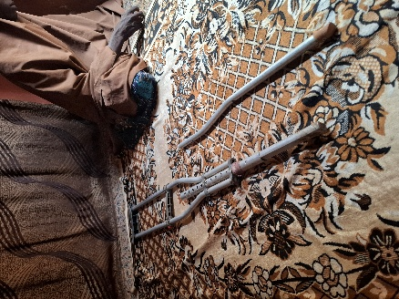
A senior official at a large international nutrition organization described losing a program that had disability inclusion as a central design element, including a near-finalized subcontract with a local Nigerian NGO to lead inclusion work and address the physical inaccessibility of nutrition centers. He called the closure "a tsunami." Replacement funding has since been secured at roughly half the prior budget, from donors who are not requesting disability-specific approaches, leaving children with disabilities part of the beneficiary population in name only. He estimated that children with disabilities are three times more likely to experience malnutrition and possible death without targeted support, and confirmed that children have died as a direct result of the closure, including cases of families abandoning a child with a disability to relocate, leaving grandparents to provide care. The organization laid off 31 staff in Nigeria as part of more than 400 layoffs globally.
Additionally, parents of children with disabilities are also experiencing health complications as a result of these closures as noted by a parent: “Since the closure of the OTL programme, [my child’ fell seriously ill… I have to donate my blood. Since that day, I have been facing health challenges.” The loss of free vaccines that were being provided by healthcare programs has led to increased fears of a future rise in disability prevalence with one government official saying, “Many children and people with disabilities have lost access to life-saving vaccines. The ripple effect of this could lead to death or permanent disability.”
Finding 5: Representative Perry's public allegation that humanitarian organizations were financing terrorism placed Nigeria-based staff under formal investigation and direct physical threat, compounding an already severe humanitarian closure.
The same nutrition official reported that his organization was subjected to a formal investigation following Representative Scott Perry's public allegations, and that he personally received death threats as a result. This occurred while the organization was simultaneously managing active child malnutrition, mass layoffs, and program closures stemming from the USAID shutdown. He described the particular weight of the accusation given the context: organizations that had spent years building trust in communities where Boko Haram had killed tens of thousands and terrorized millions were now being accused of funding that same group, and the communities they served, many of whom had lost family members to Boko Haram violence, heard the accusation directly. This finding is specific to Nigeria among the eight study countries and reflects a compounding harm beyond the loss of programming itself: humanitarian actors facing both the consequences of closure and personal danger for having done the work in the first place.
What Must Happen Next
The findings above point to concrete, actionable steps that donors, governments, and the U.S. Congress can take to address the harm documented in Nigeria and prevent its recurrence.
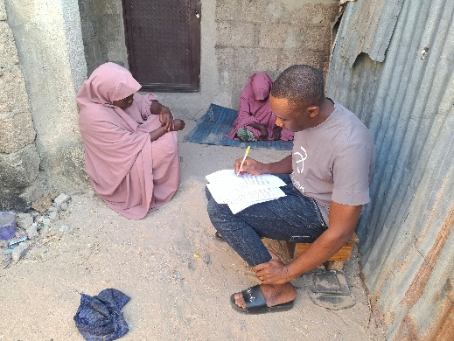
- Bilateral and multilateral donors should prioritize emergency bridge funding for OPDs in Nigeria, particularly in the northeast, where the Boko Haram security context makes community-based disability support a humanitarian and counter-extremism priority, not only a development one.
- New nutrition donors operating in Nigeria should be required to adopt disability-specific targeting and accessibility standards as a condition of funding. Children with disabilities cannot be reached through generic programming.
- The BECE fee and uniform waiver pathway secured in Borno and Yobe, and the model of recruiting Learning Facilitators with disabilities themselves, such as the Braille-qualified facilitator deployed in Adamawa, should be documented and institutionalized so they can be replicated by future programming rather than lost with the project that created them.
- The hospital MOU in Maiduguri should be restored or replaced with an equivalent commitment to free healthcare for children with disabilities.
- Any new programming in Nigeria must embed inclusive education and nutrition capacity within government systems so that inclusive practices are not dependent on any individual donor-funded project.
- Donors must adopt minimum transition planning standards so that communities in conflict-affected areas like Northeast Nigeria are never again left without notice or handover when programs end.
- U.S. government officials should refrain from public statements accusing implementing partners of funding terrorism without evidence. These statements caused direct and documented harm to organizations working to keep children alive in one of the world's most complex humanitarian contexts.
- U.S. Congress should recognize that inclusive education and nutrition programming in Northeast Nigeria is a counter-extremism investment with direct implications for U.S. national security, and fund it accordingly.

This brief draws on findings from When Programs End Overnight: The Impact of the Dismantling of USAID on Persons with Disabilities (IDP, 2026). The full report is available at www.inclusivedevpartners.org. For more information, contact Inclusive Development Partners.
Photo Credits: Suleiman Mamman, local consultant of the IDP

The Guardian Nigeria. (2026, April 30). Is Nigeria considered a rich or poor country? https://guardian.ng/nigerian/is-nigeria-considered-a-rich-or-poor-country/
United Nations Development Programme. (2024). Nigeria Multidimensional Poverty Index 2024. https://hdr.undp.org/sites/default/files/Country-Profiles/MPI2024/NGA.pdf; Institute for Security Studies Africa. (2025). Nigeria development futures. https://futures.issafrica.org/geographic/countries/nigeria/
Institute for Security Studies Africa. (2025). Nigeria development futures. https://futures.issafrica.org/geographic/countries/nigeria/
Human Rights Watch. (2016, April 11). Nigeria: Northeast children robbed of education. https://www.hrw.org/news/2016/04/11/nigeria-northeast-children-robbed-education
Human Rights Watch. (2016, April 11). They set the classrooms on fire: Attacks on education in northeast Nigeria. https://www.hrw.org/report/2016/04/11/they-set-classrooms-fire/attacks-education-northeast-nigeria
Verivafrica. (2024, April 22). Learning poverty: Policy gap and pathways to progress. https://www.verivafrica.com/insights/learning-poverty-policy-gap-and-pathways-to-progress; Teesas. (2025, March 3). The state of education in Nigeria: Challenges and opportunities. https://teesas.com/2025/03/03/the-state-of-education-in-nigeria-challenges-and-opportunities/
The Borgen Project. (2025, October 17). Education in Nigeria: Children in poverty. https://borgenproject.org/education-in-nigeria-3/
ReliefWeb. (2016). "I will never go back to school": The impact of attacks on education for Nigerian women and girls. https://reliefweb.int/report/nigeria/i-will-never-go-back-school-impact-attacks-education-nigerian-women-and-girls-summary; Refworld. (2018). Education under attack 2018: Nigeria. https://www.refworld.org/docid/5be9430613.html
Africa Center for Strategic Studies. (2022). Mitigating radicalism in northern Nigeria. https://africacenter.org/publication/mitigating-radicalism-in-northern-nigeria/; World Bank. (2017). Role of education in the prevention of violent extremism. https://documents1.worldbank.org/curated/en/448221510079762554/120997-WP-revised-PUBLIC-Role-of-Education-in-Prevention-of-Violence-Extremism-Final.pdf
USAFacts. (2026, April 23). How much foreign aid does the US provide to Nigeria? https://usafacts.org/answers/how-much-foreign-aid-does-the-us-provide/countries/nigeria/; The Punch. (2025, October 5). Nigeria gets $876m in USAID support, third in Africa. https://punchng.com/nigeria-gets-876m-usaid-support-third-in-africa/
The Punch. (2025, February 8). Calls for probe mount over $2.8bn USAID spending in Nigeria. https://punchng.com/calls-for-probe-mount-over-2-8bn-usaid-spending-in-nigeria/
Brookings Institution. (2026, April 17). USAID's aid freeze, implications for Nigeria's education sector, country responses, and new roles for external partners. https://www.brookings.edu/articles/nigeria-education-usaid-exit-responses/; CivicHive. (2025, June 16). Analyzing USAID funding freeze in Nigeria. https://civichive.org/analyzing-usaid-funding-freeze-on-nigeria/
U.S. News and World Report. (2025, March 19). Nigerian lawmakers probe USAID-funded non-profit groups, others, document shows. https://www.usnews.com/news/world/articles/2025-03-19/nigerian-lawmakers-probe-usaid-funded-non-profit-groups-others-document-shows
Naija News. (2025, February 21). Exclusive: Expert shares insight on USAID, Obama allegation, Boko Haram, terrorism in Nigeria. https://www.naijanews.com/2025/02/21/usaid-suspension-boko-haram-terrorism-in-nigeria/; The Punch. (2025, February 16). USAID: Calls for probe spread over alleged Boko Haram funding. https://punchng.com/usaid-calls-for-probe-spread-over-alleged-bharam-funding/

