COUNTRY BRIEF: NIGERIA
When Programs End Overnight: The Impact of the Dismantling of USAID on Persons with Disabilities
Inclusive Development Partners | July 2026 | www.inclusivedevpartners.org
Nepal was one of eight study countries in IDP’s mixed‑methods research on the impact of the USAID closure on persons with disabilities. Research was conducted through a global survey, key informant interviews (KIIs), and focus group discussions (FGDs) with government officials, OPD staff, implementing partners, adults with disabilities, and parents and caregivers of children with disabilities.
Country Overview
Nepal remains one of the world’s lowest income countries, with a per‑capita GDP of approximately $1,536 and persistent structural poverty, particularly in rural and mountainous regions. Persons with disabilities experience high poverty and exclusion, with national disability prevalence estimated to be 2.2%, and higher rates reported in rural districts where access to services is limited. Nepal is also highly disaster‑prone, facing recurrent earthquakes, floods, and landslides that strain government capacity and disproportionately affect persons with disabilities, who are less likely to access emergency assistance and reconstruction support. Although Nepal ratified the Convention on the Rights of Persons with Disabilities (CRPD) in 2010, government systems continue to lack sufficient technical and financial resources to implement disability‑inclusive reforms at scale.
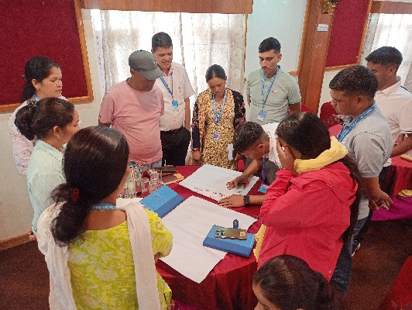
Organizations of Persons with Disabilities (OPDs) in Nepal have historically led advocacy efforts for accessible services, inclusive education, and legal reform, but they operate with limited financial resources and often rely on external funding to sustain operations and participate in policy processes. Access to therapy, rehabilitation, and early childhood services remains severely constrained outside Kathmandu Valley, with national assessments showing that children with disabilities face significant barriers to obtaining early intervention, rehabilitation, and specialized support. As a result, international development assistance plays a critical role in expanding service availability and strengthening disability‑inclusive systems nationwide.
USAID in Nepal
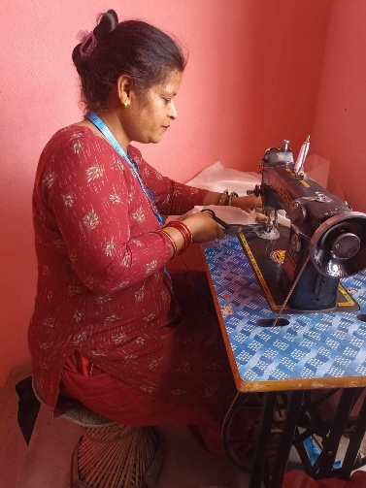
Nepal was a significant recipient of U.S. foreign assistance prior to the dismantling of USAID. The figures below reflect total U.S. foreign assistance and USAID sector allocations. Disability‑specific funding is not reported as a separate line item in publicly available data.
- Nepal received approximately $212 million in total U.S. foreign assistance in FY 2024, making it one of the largest U.S. aid recipients in South Asia. This assistance included funding for health, education, economic growth, and disaster response.

- Over the three‑year period from 2022 to 2024, Nepal received approximately $540 million in USAID funding. Health programs accounted for the largest share of USAID support, followed by humanitarian response efforts, investments in economic growth and governance, and targeted education initiatives to expand access and improve learning outcomes.
- In FY 2024, USAID managed $11.44 million for Nepal. Sector totals shown on ForeignAssistance.gov reflect all U.S. agencies combined, not USAID alone, with basic education receiving $14.05 million and health‑related sectors, such as maternal and child health, family planning, HIV/AIDS, and broader health and population programs, accounting for the largest share of total U.S. assistance to Nepal.
- Nepal received substantial U.S. disaster‑risk reduction and humanitarian assistance due to its high exposure to earthquakes, floods, and landslides. This support includes preparedness, reconstruction, and resilience programming that directly affects persons with disabilities.
- USAID was the largest bilateral donor supporting Nepal’s inclusive education reforms, including early grade learning, disability‑inclusive teacher training, and community‑based rehabilitation.
Two education programs in Nepal were terminated due to the USAID dismantling: Early Grade Learning (2023-2025) and Equity and Inclusion (2023-2025) projects, delivering inclusive education programming.
Early Grade Learning Project
USAID’s Early Grade Learning project strengthened the foundational systems required for sustainable improvements in education quality. The project supported the Ministry of Education, Science, and Technology (MOEST) and local governments in meeting School Education Sector Plan (SESP) objectives.
This $12,858,241 cooperative agreement operating across all seven provinces and 48 districts was highly successful. A few of the achievements in the first two years of operation include:
- National disability data system development: Coordinated with MOEST to develop a disability sub-system for Nepal’s national Education Management Information System (EMIS), enabling systematic identification and tracking of learners with disabilities.
- Resource classroom assessment: Conducted a nationwide assessment of resource classrooms to understand how they function in practice and what support they provide to children with disabilities.
- UDL training and materials for teachers: Developed training and resource materials on Universal Design for Learning (UDL) to promote inclusive instructional practices in early grade classrooms.
- Capacity building for government counterparts: Supported MOEST capacity building on disability inclusion, ensuring inclusive practices were integrated into planning, policy alignment, and implementation.
- Crosscutting inclusion integration: Ensured inclusion was a crosscutting priority across all EGL activities, with IDP providing technical guidance to embed disability inclusive approaches throughout the project.

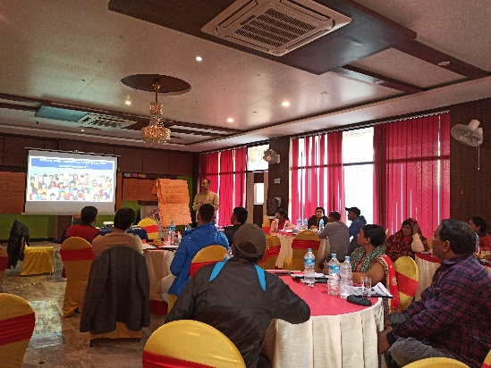
Equity and Inclusion Project
USAID’s Equity and Inclusion in Education project aimed to improve equitable education outcomes for marginalized youth in grades 6–10. The project supported local governments to bring out‑of‑school children into school, increase retention, and ensure equitable, quality learning opportunities.
This $8,263,619 cooperative agreement was also very successful. A few of the accomplishments documented before termination include:
- Alignment of teaching and learning materials with UDL and inclusive education strategies: Supported the Government of Nepal at multiple levels to align teaching, learning, and assessment materials with UDL/UDA principles and inclusive education strategies.
- Inclusive programming for marginalized learners: Ensured that all marginalized learners, including those with disabilities, both in and out of school, were intentionally included in programming and planning.
- Inclusive community engagement: Facilitated inclusive engagement with community groups, including Parent Teacher Associations (PTAs), youth organizations, and Organizations of Persons with Disabilities (OPDs).
- Strengthening government systems for equity and inclusion: Enhanced collaboration between local governments, schools, PTAs, youth groups, and provincial governments in Madhesh and Karnali Provinces to strengthen equity and inclusion systems.
- Data systems and tool development: Supported the development of data collection tools to inform program planning, monitoring, evaluation, and learning—advancing Nepal’s equity related targets.

IDP Research Findings on the Impact of the USAID Dismantling on Persons with Disabilities
SUMMARY OF THE METHODS AND RESEARCH IN NEPAL
This study employed a mixed-methods design to document the impact of USAID program terminations on persons with disabilities, their families, and the organizations and systems that served them. Data were collected concurrently through three methods: an online survey, key informant interviews (KIIs), and focus group discussions (FGDs). Findings from all streams were triangulated during analysis. In Nepal, data was collected from 3 government officials, 6 parents/caregivers of children with disabilities, and 3 OPDs. The study was conducted under Institutional Review Board (IRB) approval from the University of Massachusetts Boston.
Finding 1: Inclusive education access collapsed immediately, pushing children with disabilities out of school.
The termination of USAID programs in Nepal triggered an immediate and visible collapse in school attendance among children with disabilities. Families consistently reported that their children have experienced significant challenges continuing to attend school.
For many children with disabilities, stakeholders reported that USAID programs had provided the only pathway into education: scholarships that covered essential costs, disability cards that unlocked social benefits, mobility aids that made travel possible, and teachers trained in inclusive education who knew how to support diverse learners. Once these supports vanished, families were left without transportation, without learning materials, and without teachers equipped to include their children in the classroom.
Teachers themselves described losing coaching, mentoring, and UDL-based training that had begun to shift classroom practice. Without continued support, inclusive strategies regressed, resource classrooms remained underequipped, and children who had only recently reentered school found themselves once again excluded.
In rural districts, the impact was even more severe: children who had been identified through USAID supported screening and referred for school enrollment were left with no follow-up, no accommodations, and no specialized services. As one caregiver put it, the closure didn’t just interrupt education — it erased the fragile progress that had finally made schooling possible.
“My daughter had dropped out of school, but she was able to start going again because of this program… The organization spoke with us, helped us understand the importance of her education, and even provided her with a wheelchair.” ~Caregiver of a child with a disability in Nepal
Finding 2: Therapy and rehabilitation services disappeared overnight, leaving families without alternatives.
USAID supported therapy and rehabilitation services in Nepal were reported to often be the only services available to children with disabilities, especially in rural and mountainous districts. When the programs ended, these services vanished instantly, leaving families with no alternatives and no referral pathways.
Health camps had identified children with disabilities, conducted screenings, and promised follow-up care including physiotherapy, autism support, and referrals to specialized centers. Families were told their children would receive treatment through municipal coordination or partner facilities. Instead, the closure left them with diagnoses but no services, creating a painful gap between expectation and reality.
In remote districts like Bajura and Dadeldhura, therapy centers simply do not exist. Families cannot afford transportation to cities, and even when they reach facilities, age restrictions or cost barriers prevent access. The result is a complete collapse of early intervention and rehabilitation, precisely the services that prevent long-term disability, support developmental progress, and keep children engaged in school.
The sudden disappearance of therapy services didn’t just interrupt care; it erased the only pathway families had ever been offered.
“We do not have therapy services in our area, and we cannot afford to get services in the cities. He has multiple disabilities… We did not receive any services from the camp, only a checkup, and the doctor suggested therapy.” ~Caregiver of a child with multiple disabilities in Nepal
Finding 3: Care burdens on mothers increased sharply, and livelihood supports vanished.
USAID programs in Nepal played a critical role in reducing caregiving responsibility on mothers. Livelihood programs, self-help groups, and monthly savings schemes allowed mothers to earn income while caring for their children, participate in community networks, and access peer support.
When the programs ended, these supports collapsed. Mothers lost seed money for small businesses, monthly meeting allowances, and access to training that had begun to build economic independence. Self-help groups that had been registered or were in the process of registration lost momentum, and informal savings systems dissolved.
The impact was immediate: mothers reported being unable to leave their children with high support needs unattended, losing income, and experiencing increased stress, isolation, and emotional strain. Some caregivers had started to utilize daycare centers or participate in community groups with USAID support, only to find themselves unable to sustain them due to the sudden removal of external funding and without time to implement sustainability plans.
The closure didn’t just remove financial support, it dismantled the social and economic structures that made caregiving sustainable.
“This livelihood activity will support families like mine because I cannot leave my child alone and need to give him my full attention. Such activities allow us to take care of our children while also earning an income.” ~Caregiver of an adult with a disability in Nepal
Finding 4: Adults with disabilities lost jobs, accommodations, and health insurance.
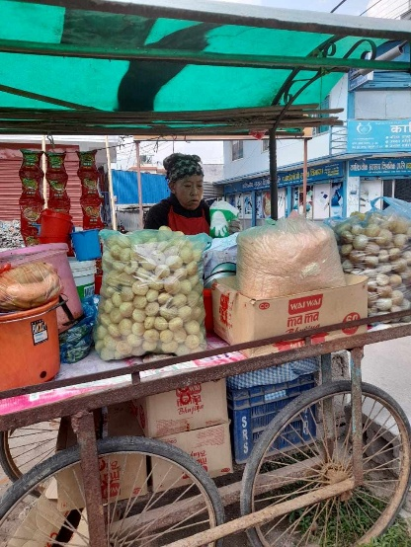
Adults with disabilities who had been employed, trained, or supported through USAID-funded programs experienced a sudden and devastating loss of income and stability. OPDs reported firing staff, shutting down operations, and halting community outreach. Individuals who had begun small businesses through seed money grants lost access to capital, markets, and mentorship.
Survey data showed that adults with disabilities were disproportionately affected by job loss compared to their non-disabled peers. 87% of persons with disabilities employed by USAID programs lost their jobs entirely, compared to 72% of those without disabilities. Nepal respondents described this as a collapse of trust and future expectations.
Many had relied on USAID programs not only for employment but also for accommodations, transportation stipends, and health-related support.
The closure also disrupted disability identity card registration drives, which had helped adults access government allowances and health benefits. Without these supports, adults with disabilities described losing trust in future programs, feeling abandoned, and facing renewed stigma in their communities.
The loss of employment wasn’t just economic, it represented a collapse of dignity, independence, and long-term opportunity.
“Employees lost their jobs… programs suspended… trainings suspended.” ~ A Nepalese OPD representative
Finding 5: Disability‑inclusive systems collapsed, reversing years of progress.
USAID programs in Nepal were strengthening disability inclusive systems at every level: national EMIS disability data, teacher training on Universal Design for Learning (UDL)/Universal Design for Assessment (UDA), resource classroom assessments, accessible learning materials, and local education planning. These were foundational reforms designed to embed inclusion into government systems.
When the programs ended, these reforms stalled instantly. Government officials described unfinished tools, unvalidated disability learning assessments, incomplete early screening across municipalities, and halted development of accessible materials such as sign language dictionaries.
Coordination mechanisms dissolved: technical advisors funded by USAID left ministries and parent networks became inactive. Local governments that had begun inclusive planning lost momentum, and out-of-school children identified through USAID programs were left without pathways into school.
The closure didn’t just pause progress, it reversed it. Systems reverted to pre-program conditions, leaving Nepal without the technical capacity, data infrastructure, or trained workforce needed to sustain disability inclusion.
“Tool development of disability learning assessment was about to complete… we had designed the initial tool but couldn’t test and validate.” ~National Government Representative
What Must Happen Next
The findings above point to concrete, actionable steps that donors, governments, and the U.S. Congress can take to address the harm documented in Nepal and prevent its recurrence.
- Donors must prioritize emergency bridge funding for OPDs and caregiver-led groups. OPDs in Nepal lost staff, operating budgets, and the ability to continue advocacy, livelihood support, and parent network activities. These organizations are the backbone of disability inclusion in Nepal’s decentralized system. Emergency funding should stabilize OPDs, restore community outreach, and rebuild parent advocacy networks that were left incomplete.
- Restore disability inclusive therapy and rehabilitation services, especially in rural districts. Therapy services disappeared overnight, leaving families with no alternatives. Donors and government partners should reestablish referral pathways and fund mobile therapy units for remote districts.
- Rebuild inclusive education supports that made school attendance possible. Children with disabilities stopped attending school because they lost mobility aids, scholarships, accessible learning materials, and teachers trained in UDL/UDA. Future programming must restore these supports immediately and embed them within government systems so they are not dependent on a single donor.
- Complete unfinished system strengthening work halted by the closure. Nepal’s disability inclusive EMIS reforms, early screening tools, sign language dictionary development, resource classroom assessments, and disability learning assessment tools were left incomplete. Donors should fund the completion, validation, and rollout of these tools so Nepal does not lose years of progress.
- Support livelihood programs that reduce care burdens and prevent long-term poverty. Livelihood training and seed money programs were essential for caregivers, especially mothers, who cannot leave their children unattended. Donors should restore livelihood programs, support self-help group registration, and rebuild informal savings and microloan systems that collapsed after closure.
- Address structural barriers: residential hostels, WASH facilities, and accessible infrastructure. Government officials emphasized that children with disabilities cannot attend school without residential hostels and safe WASH facilities. Donors should invest in disability inclusive infrastructure, especially in mountainous and remote districts where access is most constrained.
- Strengthen domestic accountability and ensure Corporate Social Responsibility (CSR) funds reach OPDs. OPDs reported that private sector CSR funds are often captured by company-owned institutions rather than reaching disability organizations. The Government of Nepal should reform CSR regulations to ensure funds flow to OPDs and community-based disability groups.

This brief draws on findings from When Programs End Overnight: The Impact of the Dismantling of USAID on Persons with Disabilities (IDP, 2026). The full report is available at www.inclusivedevpartners.org. For more information, contact Inclusive Development Partners.
Photo Credits: Samir Sodari, local consultant of the IDP

World Bank. (2025). GDP per capita (current US$) – Nepal. The World Bank Data. https://data.worldbank.org/indicator/NY.GDP.PCAP.CD?locations=NP
National Federation of the Disabled Nepal. (2023). Disability data from Nepal Census 2022. https://www.nfdn.org.np/news/disability-data/
UNPRPD. (2023). Situation analysis country brief: Nepal. United Nations Partnership on the Rights of Persons with Disabilities. https://unprpd.org/new/wp-content/uploads/2023/12/Situation_Analysis_CountryBrief_Nepal-75b.pdf
Ibid.
Ministry of Education, Science and Technology. (2020). Disability-inclusive education practices in Nepal. Government of Nepal. http://elibrary.moest.gov.np/bitstream/123456789/191/1/DISABILITY%20-INCLUSIVE%20EDUCATION%20PRACTICES%20IN%20NEPAL.pdf
USAFacts. (2025). How much foreign aid does the U.S. provide to Nepal? https://usafacts.org
USAID Foreign Aid Explorer. (2025). Nepal: U.S. foreign assistance data. https://explorer.usaid.gov
Ibid
UNICEF Nepal. (2025). Humanitarian situation report. United Nations Children’s Fund.
USAID. (2023). Nepal – Disaster Risk Reduction and Humanitarian Assistance Overview. U.S. Agency for International Development.
USAID. (2024). Nepal country profile: Foreign assistance and sector allocations. U.S. Agency for International Development.

