COUNTRY BRIEF: NIGERIA
When Programs End Overnight: The Impact of the Dismantling of USAID on Persons with Disabilities
Inclusive Development Partners | August 2026 | www.inclusivedevpartners.org
Written by Hidemi Ueno and Anna Martin with data collection done by Nazifa Tabassum Bonna
Bangladesh was one of eight study countries in IDP’s mixed‑methods research on the impact of the USAID closure on persons with disabilities. Research was conducted through a global survey, key informant interviews (KIIs), and focus group discussions (FGDs) with government officials, OPD staff, implementing partners, adults with disabilities, and parents and caregivers of children with disabilities.
Country Overview
Bangladesh is one of South Asia’s fastest‑growing economies, yet it remains highly vulnerable to poverty, climate shocks, and political instability. Despite impressive gains over the past two decades, Bangladesh’s GDP per capita remains modest, approximately $2,600 in 2025, and economic progress is increasingly threatened by inflation, currency depreciation, and climate‑related disruptions. Bangladesh has made notable strides in reducing poverty, but 18.7% of the population remains below the national poverty line in 2022, and multidimensional poverty continues to affect millions. According to the 2024 Global Multidimensional Poverty Index, Bangladesh has over 41 million multidimensionally poor people, driven by limited access to nutrition, sanitation, and education. Bangladesh’s vulnerability is compounded by its exposure to climate shocks. The country is one of the world’s most climate-affected nations, with millions of people projected to be displaced by 2050 due to sea-level rise, salinity intrusion, and extreme weather events. Cyclones, floods, and riverbank erosion repeatedly destroy homes, farmland, and infrastructure, pushing families back into poverty.
Bangladesh has made major progress in primary enrollment, yet approximately 1 million primary school-aged children and an additional 3 to 4 million secondary school-aged children are still out of school, especially in urban slums, remote rural areas, and climate-affected districts. The Rohingya crisis alone has displaced over 960,000 people, including hundreds of thousands of children who require education, protection, and psychosocial support. More than 235,000 refugee children aged 5 to 17 were estimated to be out of school, increasing their exposure to risks such as child labor, child marriage, trafficking, and other forms of exploitation. Climate shocks continue to disrupt education in Bangladesh. During the devastating 2024 floods in eastern Bangladesh, over 7,000 schools were closed and many were repurposed as shelters, leaving children without access to learning and further compounding the impacts of displacement.
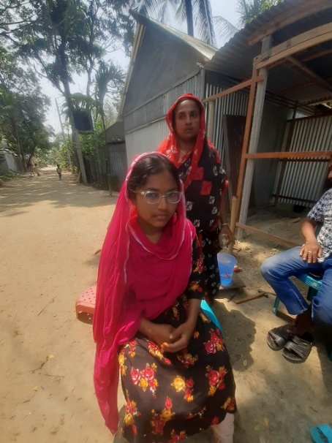
Children with disabilities in Bangladesh face some of the highest barriers to education. UNICEF’s national mapping shows that although 211 facilities across 25 districts offer education or rehabilitation services, only about one‑third are fully functional, leaving most children without consistent support. Many districts lack trained staff, accessible classrooms, or adapted materials such as braille or sign‑language resources. Children with disabilities are disproportionately excluded from school, especially in rural and low‑income areas. Schools often cannot provide individualized learning support, early identification, or continuity of care. As a result, children with disabilities are overrepresented among out‑of‑school children and less likely to complete primary or transition to secondary education. Meaningful inclusion requires investment in teacher training, accessible infrastructure, and coordinated services across health, education, and social protection systems to ensure every child can learn and participate.
USAID in Bangladesh
Bangladesh has consistently been one of the largest recipients of U.S. foreign assistance in South and Central Asia. USAID managed the majority of U.S. development funding to Bangladesh, with health and humanitarian assistance representing the largest sectors.
- Bangladesh received approximately $570 million in U.S. foreign assistance in FY 2024, according to ForeignAssistance.gov. This makes Bangladesh the 3rd largest recipient in the South and Central Asia region, behind Afghanistan and Pakistan.
- USAID managed $447 million in FY 2024, and sectors of the assistance include: humanitarian ($230 million), health and population ($59 million), agriculture ($41 million), and education ($33 million).
- Bangladesh had several major USAID education initiatives, including Esho Shikhi (“Come and Learn”), a literacy and basic education program, funded at $38.5 million, and Amar Vote, Amar Activity, civic education, and youth engagement, funded at $21 million.
Another education program in Bangladesh that was terminated due to the USAID dismantling was Shobai Miley Shikhi Activity (SMSA) (Everyone Learns Together) (2022-2025). The Bangladesh SMSA project supported national efforts to strengthen disability‑inclusive education systems in Bangladesh. The project focused on improving how the education system identifies, supports, and includes children with disabilities, and contributed technical assistance aligned with USAID’s broader commitment to improving primary education quality in Bangladesh. IDP was a partner organization for this project, providing technical support around inclusive education.
This $18 million cooperative agreement’s achievements before the termination included:
- Strengthening teacher professional development systems: Bangladesh SMSA contributed to improving teacher professional development systems, including support for training approaches that help teachers better include children with disabilities in mainstream classrooms.
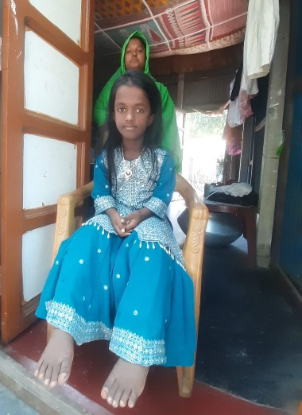
- Support for national‑level policy and system strengthening: The project provided technical assistance to strengthen national policies and systems related to disability‑inclusive education. This included collaboration with government counterparts to integrate disability inclusion into broader education system reforms.
- Contribution to USAID’s national primary education improvement efforts: The project’s work aligns with USAID’s broader initiative to improve primary education quality in Bangladesh, including efforts to enhance learning outcomes, strengthen teacher training, and improve school‑level support structures.
- Support for coordination mechanisms within the education system: Bangladesh SMSA helped strengthen coordination mechanisms that support disability‑inclusive education, ensuring that system‑level reforms are aligned and sustainable.
IDP Research Findings on the Impact of the USAID Dismantling on Persons with Disabilities
SUMMARY OF THE METHODS AND RESEARCH IN BANGLADESH
This study employed a mixed-methods design to document the impact of USAID program terminations on persons with disabilities, their families, and the organizations and systems that served them. Data were collected concurrently through three methods: an online survey, key informant interviews (KIIs), and focus group discussions (FGDs). Findings from all streams were triangulated during analysis. In Bangladesh, data was collected from 4 government officials, 6 parents/caregivers of children with disabilities, and 2 OPDs. The study was conducted under Institutional Review Board (IRB) approval from the University of Massachusetts Boston.
Finding 1: Inclusive education access declined immediately, reducing school attendance and support for children with disabilities.
Across all respondent groups, school attendance dropped sharply once USAID-supported activities ended. Parents described a return to pre‑project conditions, with children losing motivation and teachers no longer following up. Children with disabilities who had begun attending regularly during the project became inconsistent or stopped altogether:
“She goes to school but not regularly…”
- Parent of a Child with a Disability, Bangladesh
“What I have noticed is that some students with disability who were getting regular in classrooms are most of the time remains absent from the school.”
- Government Officer, Bangladesh
Without project staff, inclusive classroom practices weakened, and children, especially those with intellectual, hearing, and physical disabilities, lost the structured support that had enabled their participation.
Finding 2: Teacher training and UDL-based inclusive practices collapsed, reversing system-wide progress.
Government officials reported that thousands of teachers lost access to planned training, refresher sessions, and mentoring. Teachers who had begun applying inclusive methods were left without guidance, materials, or follow-up.
“Approximately 30,000 teachers from all over the country didn’t get to receive the training.
- Government Officer, Bangladesh
“Without follow-up training, it is difficult for teachers to maintain the same level of quality.”
- Government Officer, Bangladesh
Parents noticed the decline immediately, describing reduced attention and fewer adapted materials in classrooms. The collapse of training and mentoring led to regression in inclusive teaching practices across project schools.

Finding 3: Referral pathways, rehabilitation linkages, and assistive device access disappeared, leaving families without alternatives.
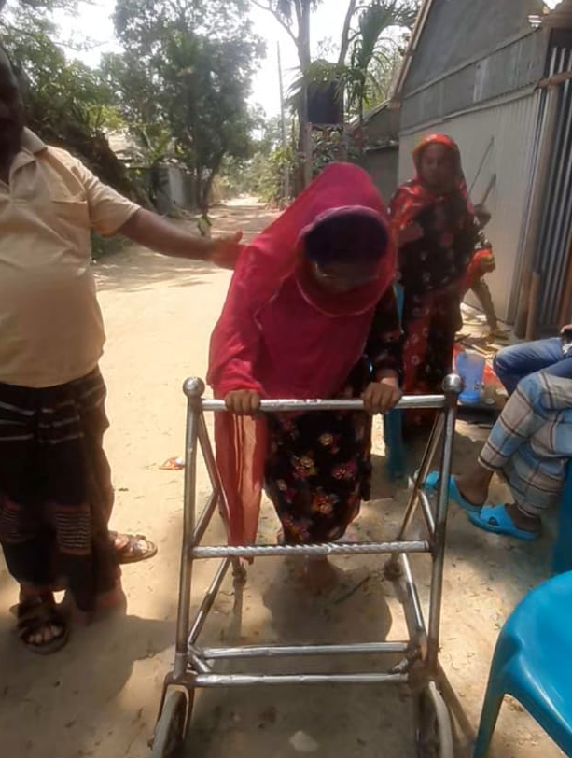
The project had served as an informal but critical referral system for therapy, health services, and assistive devices. After closure, families were left without information or access.
“Referrals to therapy or health services are not as organized now. Families don’t always know where to go.”
- Government Officer, Bangladesh
“It is difficult to get devices now.”
- OPD representative, Bangladesh
Parents described unmet needs for hearing devices, wheelchair servicing, and mobility support, with no clear pathways to obtain them. The disappearance of these services created immediate gaps in children’s daily functioning and access to school.
“The wheelchair of my daughter is facing some issues. But we don’t know where to go for servicing this without spending so much money.”
- Parent of a child with a disability, Bangladesh
Finding 4: Livelihood supports, OPD engagement, and community inclusion activities collapsed, increasing economic and social vulnerability.
OPDs lost training opportunities, financial support, and connections to government offices. Livelihood activities that had begun under the project became unsustainable.
“We don’t have funds to run activities like before.”
- OPD representative, Bangladesh
“OPD members are becoming less active again.”
- OPD representative, Bangladesh
Community awareness activities, especially mothers’ meetings, stopped abruptly, reducing peer support and weakening inclusive attitudes:
“There used to be monthly “mothers meeting” as a part of the project’s activity. That was a great community awareness raising program in my area. Mothers/caregivers used to participate very enthusiastically on those meetings. But now that community engagement is no longer available which is very sad.”
- Government Officer, Bangladesh
Caregivers reported increased burdens and isolation, with no replacement support.

Finding 5: Disability‑inclusive systems collapsed, reversing years of progress.
Government officials described halted system-strengthening efforts, including teacher training module development, integration into national plans, and coordination structures. OPDs lost access to government offices and networks, and parents and OPDs expressed declining trust in sustainability.
“During the project period, everyone was very active about the issue. Now, coordination meetings and awareness activities are no longer held like before, so the issue is gradually losing importance.”
- Government Officer, Bangladesh
“But now that the projects have been closed the connections and our access to these offices have also reduced.” And, “Communication with local NGOs have also reduced significantly – OPD representative
“People now think these projects are temporary. They don’t have any larger goal or sustainability.” – OPD representative
The closure reversed momentum toward institutionalizing inclusive education within government systems.
What Must Happen Next
The findings above point to concrete, actionable steps that donors, governments, and the U.S. Congress can take to address the harm documented in Bangladesh and prevent its recurrence.
- Restore structured teacher training and Universal Design for Learning (UDL)‑based inclusive education. Teacher training must be reinstated so teachers regain the skills, confidence, and materials needed to support children with disabilities. Without structured refresher courses and foundational training for new teachers, inclusive practices will continue to deteriorate.
- Rebuild referral pathways and access to rehabilitation and assistive devices. Families need clear, accessible referral systems for therapy, mobility support, and assistive devices, especially in rural areas where services are scarce. Without restored referral pathways, children’s functional needs will remain unmet and school participation will continue to decline.
- Reestablish community awareness and parent engagement mechanisms. Community engagement activities, such as Mothers’ Meetings, must resume to reinforce inclusive attitudes, reduce stigma, and strengthen parent confidence. Without these mechanisms, families will remain isolated and children with disabilities will face increased barriers to attending school.
- Provide livelihood and financial support to OPDs and families. OPDs require financial assistance and skills training to rebuild their operational capacity and continue supporting members. Families also need targeted livelihood and disability‑related financial support to manage transport, assistive devices, and caregiving responsibilities.
- Complete unfinished system-strengthening work and integrate inclusive education into government systems. Key reforms, such as updated teacher training modules, disability data systems, and integration into PEDP 5, must be completed and institutionalized. Without finishing this work, Bangladesh risks losing years of progress and returning to fragmented inclusive education practices.
- Strengthen coordination across education, social welfare, and local government. Coordination mechanisms must be rebuilt through regular multi‑department meetings and joint planning to ensure coherent service delivery. Without restored coordination, inclusive education cannot function as a system and gaps will continue to widen.
- Ensure sustainability planning and transition mechanisms in all future projects. Future programs must include clear roadmaps for government takeover, phased transitions, and contingency plans to protect vulnerable groups. Without sustainability planning, any future gains will remain fragile and easily reversed.
This brief draws on findings from When Programs End Overnight: The Impact of the Dismantling of USAID on Persons with Disabilities (IDP, 2026). The full report is available at www.inclusivedevpartners.org. For more information, contact Inclusive Development Partners.
Photo Credits: Nazifa Tabassum Bonna, local consultant of the IDP

World Bank. (2024). GDP per capita (current US$) – Bangladesh. World Bank Open Data. https://data.worldbank.org/indicator/NY.GDP.PCAP.CD?locations=BD
Asian Development Bank. (2024). Bangladesh: Poverty data. ADB. https://www.adb.org/where-we-work/bangladesh/poverty
United Nations Development Programme. (2024). Bangladesh: Multidimensional Poverty Index (MPI) Country Profile. UNDP. https://hdr.undp.org/sites/default/files/Country-Profiles/MPI2024/BGD.pdf
World Bank. (2025). Bangladesh Country Profile. World Bank. https://www.mhewc.org/wp-content/uploads/2025/09/16813-WB_Bangladesh-Country-Profile-WEB.pdf
Dhaka Tribune. (2026). ESA 2026: Bangladesh faces learning crisis despite progress. Dhaka Tribune. https://www.dhakatribune.com/bangladesh/education/412614/esa%C2%A02026-%C2%A0bangladesh%C2%A0faces%C2%A0learning%C2%A0crisis%C2%A0despite
UNICEF. (2024). Rohingya crisis: Impact on children. UNICEF. https://www.unicef.org/emergencies/rohingya-crisis#impact-children
UNICEF. (2024). Climate displacement, loss and uncertain futures. UNICEF Bangladesh. https://www.unicef.org/bangladesh/en/stories/climate-displacement-loss-and-uncertain-futures
UNICEF. (2024). Education. UNICEF Bangladesh. https://www.unicef.org/bangladesh/en/education
UNICEF. (2024). Services mapping for children with disabilities in Bangladesh. UNICEF Bangladesh. https://www.unicef.org/bangladesh/en/media/11981/file/Services%20Mapping%20for%20Children%20with%20Disabilities%20in%20Bangladesh.pdf.pdf
Winrock International. (2024). USAID and the Ministry of Primary and Mass Education launch new project to improve quality of early education. Winrock International. https://winrock.org/usaid-and-the-ministry-of-primary-and-mass-education-launch-new-project-to-improve-quality-of-early-education/
Inclusive Development Partners. (2024). Bangladesh SMSA. Inclusive Development Partners. https://www.inclusivedevpartners.com/bangladesh-smsa/
RTI International. (2024). RTI partnering with USAID and Government of Bangladesh to ensure quality primary education. RTI International. https://www.rti.org/announcements/rti-partnering-usaid-and-government-bangladesh-ensure-quality-primary-education
U.S. Embassy Dhaka. (2024). USAID launches new initiative to improve primary education in Bangladesh. U.S. Department of State. https://bd.usembassy.gov/28832/

