COUNTRY BRIEF: Malawi
When Programs End Overnight: The Impact of the Dismantling of USAID on Persons with Disabilities
Inclusive Development Partners | August 2026 | www.inclusivedevpartners.org
Written by Anne Hayes, Hidemi Ueno, and Anna Martin. Research conducted by Augustine Kanyendula and Stuart Chauluka.
Malawi was one of eight study countries in IDP’s mixed‑methods research on the impact of the USAID closure on persons with disabilities. Research was conducted through a global survey, key informant interviews (KIIs), and focus group discussions (FGDs) with government officials, OPD staff, implementing partners, adults with disabilities, and parents and caregivers of children with disabilities.
Country Overview
Malawi is a low‑income, landlocked country with entrenched structural poverty, high climate vulnerability, and limited economic diversification. GDP per capita remains below $800 in nominal terms, and gross national income per capita is estimated at around $606, placing Malawi firmly in the Least Developed Country category. More than 70% of the population lives below the international poverty line of $2.15 per day, and an estimated three‑quarters of Malawians were below $3 per day in 2025, reflecting stagnant per‑capita growth and low productivity in agriculture. Economic mobility is constrained by a narrow economic base heavily reliant on smallholder farming, limited formal employment opportunities, and recurrent macroeconomic instability, including high inflation and currency depreciation. While remittances and informal transfers help households cope with shocks, they are insufficient to offset chronic underinvestment in infrastructure, social services, and rural livelihoods.

Malawi’s development trajectory has been shaped by cycles of food insecurity, economic stress, and localized violence linked to resource scarcity rather than organized gang structures. Over the past decade, repeated climate‑related disasters and rising food prices have deepened hardship. According to the World Bank’s 2025 Poverty & Equity Brief, 51% of Malawians remain below minimum caloric intake, and in 2024 nearly three‑quarters of households reported inadequate food in the past month, reflecting severe and persistent food insecurity. These conditions have eroded trust in institutions and strained community cohesion, particularly in rural districts where livelihoods depend almost entirely on rain‑fed agriculture. Although Malawi maintains relative political stability and democratic governance, high poverty, youth unemployment, and limited state capacity to deliver services continue to fuel social tensions and increase the risk of localized conflict and displacement.

Malawi is among the most climate‑vulnerable countries in Southern Africa. Recurrent shocks, including Cyclone Idai (2019), Cyclone Ana and Tropical Storm Gombe (2022), Cyclone Freddy (2023), and El Niño‑induced droughts in 2024, have devastated crops, damaged infrastructure, and pushed millions into acute food insecurity. Agriculture employs over two‑thirds of the population and contributes roughly a quarter of GDP, yet 76% of smallholders cultivate plots smaller than one hectare, often without irrigation, insurance, or access to climate‑resilient inputs. Climate shocks have kept maize production below recent averages and left large national food gaps, while high food price inflation further undermines household resilience. These environmental pressures compound existing social inequities and threaten to reverse gains in human development, including improvements in child mortality and fertility reduction.

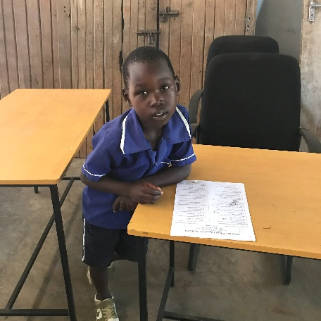
Education access in Malawi remains uneven and highly sensitive to poverty and climate shocks. While primary school net enrollment is relatively high at around 88% (2022), secondary school gross enrollment is only about 32% (2022), and lower secondary completion stands near 26.5%, reflecting high dropout rates and limited progression. Learners with disabilities face even steeper barriers: the 2024/2025 Malawi Education Statistics Report shows that students with special educational needs (SNE) make up only about 4% of total primary enrollment, but their representation drops sharply to 2.7% at the secondary level, indicating a severe “transition cliff.” Additionally, 17% of students with disabilities report that schools are not physically accessible, and Malawi’s 2019–20 MICS survey estimates that 12% of children nationwide have a disability, many of whom are disproportionately excluded from schooling. Economic hardship, early marriage, teenage pregnancy (which has risen to about 32% in 2024), and the need for children to contribute to household labor all drive early school leaving, especially among girls and rural youth. As a result, Malawi faces a persistent skills gap: many young people lack the training and qualifications needed to access formal employment or participate in emerging sectors beyond subsistence agriculture.

Persons with disabilities in Malawi experience additional barriers to inclusion and access to services. National indicators show high levels of stunting (around 34%) and significant maternal mortality (about 381 deaths per 100,000 live births), underscoring broader health and nutrition challenges that intersect with disability. Rehabilitation services, assistive devices, and inclusive education are limited, particularly outside major urban centers, and many disability‑inclusive policies remain under‑implemented due to resource constraints and weak institutional capacity. Organizations of Persons with Disabilities (OPDs) play a critical role in advocating for rights and services, but they often operate with constrained funding and limited technical knowledge to influence policy processes.

Given these intersecting challenges, structural poverty, recurrent climate shocks, food insecurity, and limited inclusive service delivery, sustained external development investment in Malawi is foundational rather than supplementary. Evidence from community‑based and social protection programs shows that expanding access to quality education, climate‑smart agriculture, vocational training, nutrition and health services, and disability‑inclusive support can strengthen household resilience, reduce negative coping strategies (such as distress migration or child labor), and create pathways to long‑term economic stability. Targeted investment in marginalized rural communities and climate‑affected regions is essential to ensure that demographic shifts, such as declining fertility, translate into durable, equitable development outcomes and that Malawi can gradually move out of extreme poverty and vulnerability.

USAID in Malawi
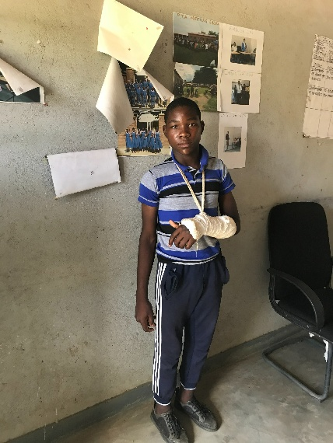
Malawi has been a long‑standing partner of the United States, receiving sustained U.S. foreign assistance focused on health, food security, climate resilience, education, governance, and economic growth. USAID was one of Malawi’s largest bilateral donors, particularly in health, agriculture, and humanitarian response. Disability‑specific funding is not reported as a separate line item in publicly available U.S. government data.
- Malawi received approximately $737 million in total U.S. foreign assistance in FY 2024. This includes investments across infrastructure, health and population, education, and humanitarian assistance.
- In FY 2024, USAID managed $274 million for Malawi. Sector totals on ForeignAssistance.gov show health and population receiving $140 million, education receiving $36 million, and humanitarian programs receiving $30 million.
- Malawi receives substantial U.S. humanitarian and disaster‑risk reduction assistance due to its extreme climate vulnerability. USAID’s Bureau for Humanitarian Assistance (BHA) provided support for:
  - Cyclone Idai (2019), Cyclone Ana (2022), and Cyclone Freddy (2023) response
  - El Niño‑related drought assistance (2024–2025).
  - Early warning systems, community‑level disaster preparedness, and climate‑resilient agriculture.
These programs directly benefit vulnerable populations, including persons with disabilities, who are disproportionately affected by climate shocks.

USAID was one of Malawi’s largest bilateral donors supporting education, youth inclusion, and skills development. Key USAID investments included:
- Literacy, Teaching, Curriculum:
  - Early Grade Reading through the National Reading Program
  - Teacher Training and Curriculum Reform
- Inclusive Education
  - Inclusive Education, focusing on policy development, school accessibility improvements and community-based initiatives that expand learning opportunities for children and youth with disabilities
  - Girls’ education and safe learning environments, including programs addressing early marriage and school dropout.
- Youth skills and workforce development
  - Technical and vocational education and training (TVET) for youth,
  - Digital skills
  - Workforce development
- Psychosocial support
  - Community based psychosocial support, especially in disaster affected districts.

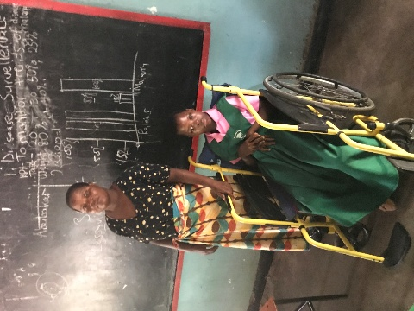
Programs in Malawi were terminated as a result of USAID's dismantling, including the Malawi Next Generation (NextGen) Early Grade Reading Activity (2022-2025). IDP was a technical partner delivering disability‑inclusive education programming. The project aimed to strengthen inclusive early grade reading instruction as part of Malawi’s National Reading Program (NRP). The Activity aimed to ensure that at least 30% of Malawian second‑grade learners were achieving grade‑level reading proficiency in Chichewa, and that beneficiaries demonstrated measurable improvements in English oral expression and reading sub‑skills.
This $74 million USAID‑funded contract operated across Malawi’s primary schools, applying a twin‑track inclusion model: 1) ensuring all project activities and materials were designed with an inclusion lens; and 2) implementing disability‑targeted interventions to address the diverse needs of learners with disabilities. Key achievements in the first years of implementation included:
- UDL integration into national teacher training materials: IDP provided extensive feedback to embed Universal Design for Learning (UDL) principles into the Training‑of‑Trainers (ToT) Facilitator’s Guide used for teacher training. Their recommendations were accepted and fully integrated into the guide.
- Review and strengthening of National inclusive education strategy (NIES) and Malawi’s draft Inclusive Education (IE) Policy: IDP worked with USAID and the Ministry of Education (MoE) to review the NIES and draft national Inclusive Education Policy, ensuring alignment with international standards such as reasonable accommodation, dignity, autonomy, and the right to be heard.
- Strengthening Malawi’s inclusive education system: IDP led various activities to support inclusive education throughout the country, this includes:
  - development and implementation of inclusive School Improvement Plans (SIPs)
  - development of resource center standards
- Inclusion of learners with disabilities in national reading assessments: IDP’s All Children Learning Specialists (ACLS) collaborated with EdIntersect to determine realistic approaches for assessing literacy development among learners with disabilities in both resource classrooms and general education classrooms. The team conducted school visits in Lilongwe and held debriefs to identify meaningful ways to include students with disabilities in NextGen assessments.

IDP Research Findings on the Impact of the USAID Dismantling on Persons with Disabilities
SUMMARY OF THE METHODS AND RESEARCH IN MALAWI
This study employed a mixed-methods design to document the impact of USAID program terminations on persons with disabilities, their families, and the organizations and systems that served them. Data were collected concurrently through three methods: an online survey, key informant interviews (KIIs), and focus group discussions (FGDs). Findings from all streams were triangulated during analysis. In Malawi, data was collected from 9 government officials, 8 persons with disabilities and parents/caregivers of children with disabilities, and 3 OPDs. The study was conducted under Institutional Review Board (IRB) approval from the University of Massachusetts Boston.
The findings below are drawn entirely from evidence collected across Salima, Lilongwe, Dowa, Mangochi, Zomba, Ntcheu, Mwanza, Karonga, and Blantyre, including caregivers, adults with disabilities, OPDs, rehabilitation officers, district social workers, and national‑level officials.
Finding 1: Educational inclusion deteriorated sharply, leaving many children with disabilities without meaningful access to schooling.
Across all districts, caregivers, OPDs, and education officials described a rapid collapse of inclusive education supports after USAID’s closure. Students lost access to adequate accessible learning materials (braille, large print books, digital tools), teacher training halted, and resource centers became less functional due to lack inadequate financial and material support of maintenance funds. Children with disabilities began missing school, losing motivation, or dropping out entirely.
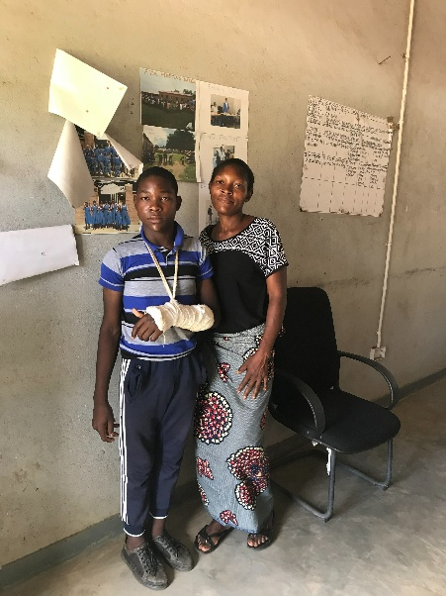
“My child is no longer motivated to go to school.”
– Caregiver, Salima

“Without accessible learning materials, students with visual impairments are likely to miss school and eventually drop out.”
– Adult who is blind, Zomba

Government officials confirmed that inclusive education systems stalled:

“No school materials, no schooling.”
– Government Representative, Ntcheu

“Learners with disabilities are the ones who are affected most when these programs stop.”
– Government Representative, Lilongwe

The loss of USAID‑funded teacher training, accessible materials, and resource center support created immediate barriers for learners who are deaf, blind, low‑vision, or have physical disabilities. Schools are reverting to pre‑USAID conditions: less accessible classrooms, teachers not receiving further training, and no new disability‑friendly materials.
Finding 2: Rehabilitation and health services contracted severely, especially for rural families.
USAID had supported rehabilitation outreach, mobile clinics, assistive device distribution, and referral systems. After closure, these systems collapsed resulting in denial of services to the poorest of families.

“Frankly speaking, we are not really working as we use to, during USAID funding.”
– Government Official, Mwanza

“Without assistive devices or therapy, daily activities become much more difficult.”
– Government Official, Lilongwe

Children with disabilities lost access to therapy, early identification, and mobility aids:

“If the wheelchair breaks, there is no one to fix it.”
– Caregiver, Salima

“Now he gets sick more often because he does not have the same food support.”
– Caregiver of blind HIV‑positive child, Dowa

Mobile clinics that previously reached rural communities shut down, forcing families to travel long distances to district hospitals, often impossible due to cost and physical barriers.

Finding 3: Caregiving burdens intensified dramatically, especially for mothers, while psychosocial and economic supports disappeared.
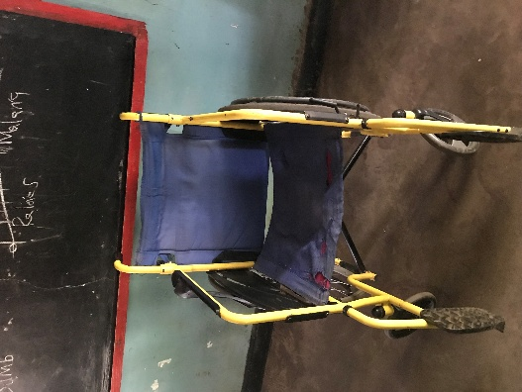
Across Malawi, caregivers described a sudden increase in daily responsibilities. USAID‑funded programs had provided caregiver support groups, psychosocial counseling, parent training, sign language classes, small business inputs, nutritional support for HIV‑positive children, transport assistance, etc. All of these ended abruptly. Caregivers described emotional and economic strain:

“Before, we felt supported. Now we feel alone.”
– Caregiver, Lilongwe

“I am now responsible for everything.”
– Caregiver, Salima

“We struggle even for food. We cannot manage extra costs.”
– Caregiver, Lilongwe

Women caregivers, who already carried the majority of care responsibilities, lost the only structured support systems available to them. Many reported increased isolation, anxiety, and financial hardship.
Finding 4: Adults with disabilities lost employment, mobility supports, and access to services tied to USAID programming.
Adults with disabilities who previously worked as peer educators, community mobilizers, or OPD staff lost jobs and stipends. This triggered cascading losses: inability to afford transport, loss of access to assistive devices, reduced participation in community life, and collapse of OPD outreach.

“It felt like a death in the family. We were just starting to stand on our own economically, and then the crutches were kicked away.”
– Adult who is blind, Zomba

OPDs reported severe operational decline:

“We had to terminate at least 50% of staff contracts, allowing those affected to work on a voluntary basis until new funding is secured.”
– OPD leader, Blantyre

“USAID funding kickstarted OPD visibility, but now OPDs must drive their own growth to attract new partners.”
– OPD representative, Blantyre

Territorial coverage shrank dramatically, leaving rural communities without disability advocacy or services.
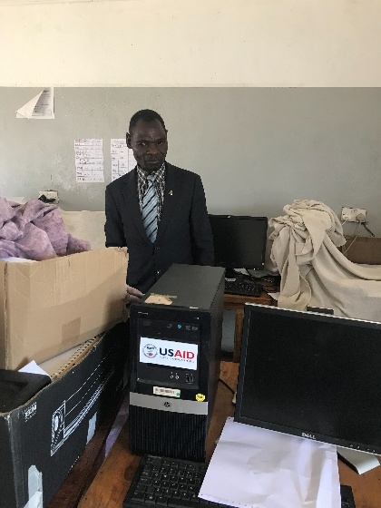
Finding 5: Malawi’s disability‑inclusive systems weakened significantly, reversing years of gradual progress.
Government officials across ministries described systemic regression:

“The system has gone back to the drawing board.”
– Government Official, Lilongwe

“We are just standing still; we are moving backward. Coordination meetings between ministry departments and stakeholders have stopped because the funding for these platforms has dried up."
– Government Official, Mwanza

Key systems collapsed: disability identification and referral pathways, inclusive education policy launch and rollout, resource center development, teacher training pipelines, rehabilitation outreach, disability‑disaggregated data collection, and OPD–government coordination platforms. Assistive device supply chains broke down leading to a shortage of wheelchairs, hearing aids, and medical supplies.
Social protection gaps widened:

“Only few persons with disabilities are accessing social cash transfer.”
– Government officer, Mwanza

The system reverted to fragmented, under‑resourced conditions similar to those before USAID engagement.
What Must Happen Next
The Malawi findings point to urgent, concrete actions needed to prevent long‑term harm and rebuild disability‑inclusive systems.
- Donors must rapidly restore funding to Malawi’s OPDs who lost staff, outreach capacity, and operational funding. They are the primary lifeline for families who lost access to services.
- Inclusive education investments must be reinstated. This includes accessible learning materials (Braille, large print books, digital tools), teacher training in inclusive education and UDL, resource center rehabilitation, sign language training for teachers and parents, support towards boarding facilities for students with special education needs, and transportation support for rural learners. Without these, children with disabilities will continue dropping out.
- Rehabilitation and assistive device services must be rebuilt. Priority needs include mobile rehabilitation clinics, assistive device procurement and repair, early identification and referral systems, and rehabilitation workforce training. Rural families cannot access district hospitals without support.
- Economic inclusion programs for caregivers must be restored. Caregivers need seed capital, small business inputs, savings groups, agricultural support, and disability-targeted social protection. These were one of the only viable income pathways for caregivers who cannot work outside the home.
- Malawi’s disability systems require structured rebuilding. This includes disability registries, referral pathways, community outreach mechanisms, inclusive education best practices, policy implementation, and resource center standards [and] rollout. Government officials repeatedly emphasized that these systems stalled after USAID’s closure.
- Donors must adopt mandatory transition protocols. Malawi’s evidence shows that abrupt program termination causes immediate service collapse, deepening vulnerability for children and adults with disabilities.
- U.S. government agencies must protect disability inclusive programming from political reversals. Accessible materials, sign language interpretation, and disability disaggregated data must be safeguarded from elimination under broad executive orders.
- U.S. Congress should recognize disability inclusive programming in Malawi as a stabilizing force. In rural districts where poverty, disability, and limited public services intersect, inclusive education, rehabilitation, and caregiver support are essential for community resilience and long-term development.

This brief draws on findings from When Programs End Overnight: The Impact of the Dismantling of USAID on Persons with Disabilities (IDP, 2026). The full report is available at www.inclusivedevpartners.org. For more information, contact Inclusive Development Partners.
Photo Credits: Augustine Kanyendula, local consultant of the IDP

Zipdo. (n.d.). Malawi statistics. https://zipdo.co/malawi-statistics/?utm_source=copilot.com
United Nations Department of Economic and Social Affairs. (n.d.). Least developed country category: Malawi profile. https://policy.desa.un.org/themes/least-developed-countries-category/least-developed-country-category-malawi-profile?language_content_entity=en&utm_source=copilot.com
Institute for Security Studies. (n.d.). Malawi country futures profile (2026). https://futures.issafrica.org/geographic/countries/malawi/index.html?geography=2026&utm_source=copilot.com
World Bank. (2023). Malawi economic update [Report]. https://documents1.worldbank.org/curated/en/099733404212517163/txt/IDU-9f3c95bc-67f3-4066-af90-8b6f5d910d81.txt?utm_source=copilot.com
Institute for Security Studies. (n.d.). Malawi country futures profile (2026). https://futures.issafrica.org/geographic/countries/malawi/index.html?geography=2026&utm_source=copilot.com
World Bank. (2023). Malawi economic update [Text version]. https://documents1.worldbank.org/curated/en/099733404212517163/txt/IDU-9f3c95bc-67f3-4066-af90-8b6f5d910d81.txt
Institute for Security Studies. (n.d.). Malawi country futures profile (2026). https://futures.issafrica.org/geographic/countries/malawi/index.html?geography=2026
World Bank. (2023). Malawi economic update [PDF]. https://documents1.worldbank.org/curated/en/099733404212517163/pdf/IDU-9f3c95bc-67f3-4066-af90-8b6f5d910d81.pdf
Zipdo. (n.d.). Malawi statistics. https://zipdo.co/malawi-statistics/
United Nations Department of Economic and Social Affairs. (n.d.). Least developed country category: Malawi profile. https://policy.desa.un.org/themes/least-developed-countries-category/least-developed-country-category-malawi-profile
Link Education. (2024). RISE Year 2 and 3 briefing: Malawi [PDF]. https://linkeducation.org.uk/wp-content/uploads/2024/10/RISE-Y2-and-3-briefing-Malawi.Final_-2.pdf
London School of Hygiene & Tropical Medicine. (2023). Education and disability in Malawi: Evidence brief [PDF]. https://www.lshtm.ac.uk/media/92131
World Bank. (2023). Malawi economic update [PDF]. https://documents1.worldbank.org/curated/en/099733404212517163/pdf/IDU-9f3c95bc-67f3-4066-af90-8b6f5d910d81.pdf
UNICEF Malawi. (2024). Education and child protection brief [PDF].
Malawi24. (2026, January 29). Malawi’s skills gap widens as thousands of youths vie for 10,000 training slots. https://malawi24.com/2026/01/29/malawis-skills-gap-widens-as-thousands-of-youths-vie-for-10000-training-slots/
United Nations Department of Economic and Social Affairs. (n.d.). Least developed country category: Malawi profile. https://policy.desa.un.org/themes/least-developed-countries-category/least-developed-country-category-malawi-profile
Global Disability Fund. (2025). Situation analysis of persons with disabilities in Malawi [Full report]. https://globaldisabilityfund.org/new/wp-content/uploads/2025/10/SitAn-Malawi-Full-Report.pdf
World Bank. (2023). Malawi economic update [Text version]. https://documents1.worldbank.org/curated/en/099733404212517163/txt/IDU-9f3c95bc-67f3-4066-af90-8b6f5d910d81.txt
ForeignAssistance.gov. (2024). Malawi: U.S. foreign assistance obligations. https://foreignassistance.gov/cd/malawi/1/2024/obligations
USAID. (2019). 5 ways the U.S. is responding to Cyclone Idai. https://usaidsaveslives.medium.com/5-ways-the-u-s-is-responding-to-cyclone-idai-80058c153c3e
UNICEF. (2022, February 15). Malawi humanitarian situation report: Tropical Storm Ana [PDF]. https://www.unicef.org/media/115671/file/Malawi%20Humanitarian%20Situation%20Report%20(Tropical%20Storm%20Ana),%2015%20February%202022%20.pdf
U.S. Embassy Lilongwe. (2023). United States provides $4 million to bolster Cyclone Freddy recovery and cholera prevention. https://mw.usembassy.gov/united-states-provides-4-million-to-bolster-cyclone-freddy-recovery-and-cholera-prevention/
Maravi Express. (2024). US government injects MK12 billion as additional humanitarian assistance towards Malawians affected by El Niño-induced drought. https://www.maraviexpress.com/us-government-injects-mk12-billion-as-additional-humanitarian-assistance-towards-malawians-affected-by-el-nino-induced-drought/
UNICEF Malawi. (2024). Education budget brief [PDF].
Inclusive Development Partners. (n.d.). Malawi NextGen Early Grade Reading Activity. https://www.inclusivedevpartners.com/malawi-nextgen/

